**Dominic Townsend’s Programming Tutorials**

**Random Sound Effects**

1. Create a GameObject called “Player”, and place it in the scene.

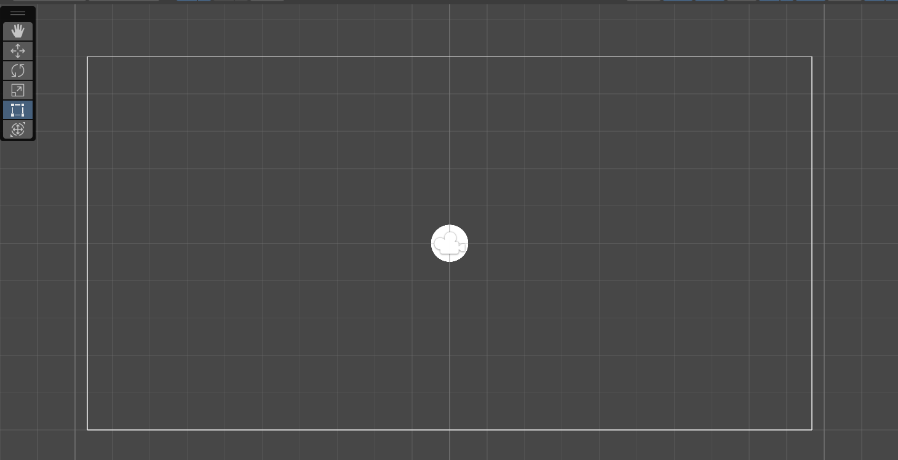

2. Find or create a series of footstep audio clips, where each clip is one footstep. Create an audio folder in the project files and move them there.

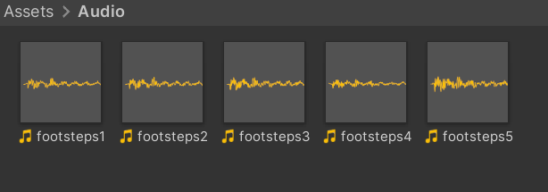

3. Attach an Audio Source to the player, and keep it at its default settings. The AudioClip will eventually be sourced from series of sound effects.

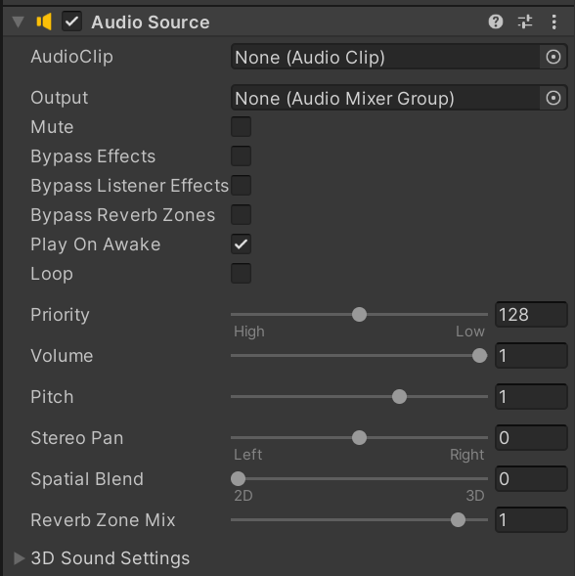

4. Create a script called “PlayerMovement.cs”, which gives the player basic top-down movement abilities.

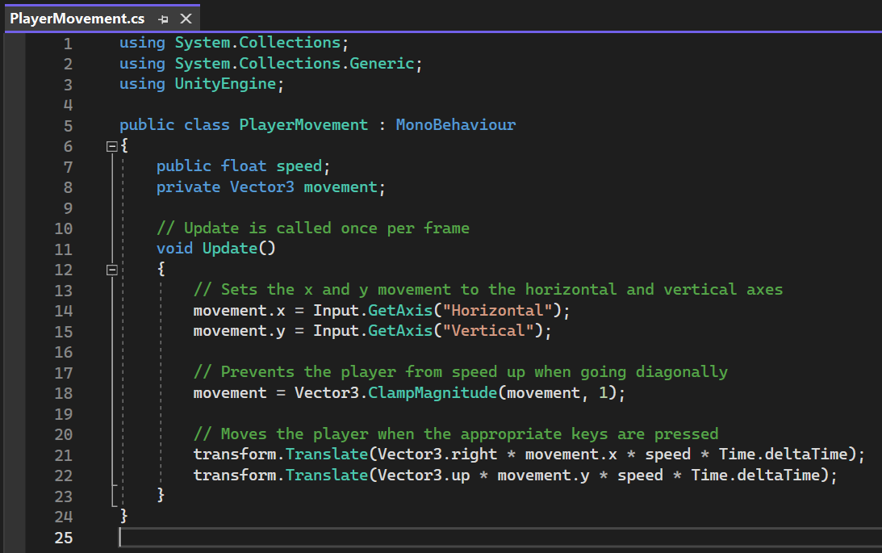

5. Attach this script to the player GameObject, and adjust the speed in the inspector to your liking.

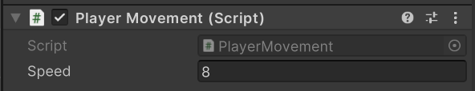

6. The player should now be able to move around the scene.

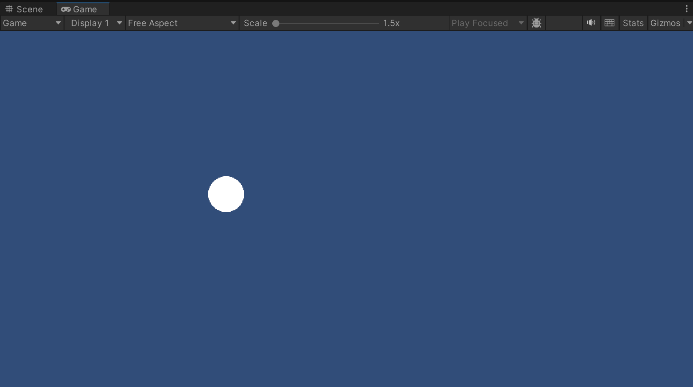

7. Create another script called “AudioManager.cs”. The following code will check if the player’s moving and play a random selection of sounds, one after another, until no movement is detected.

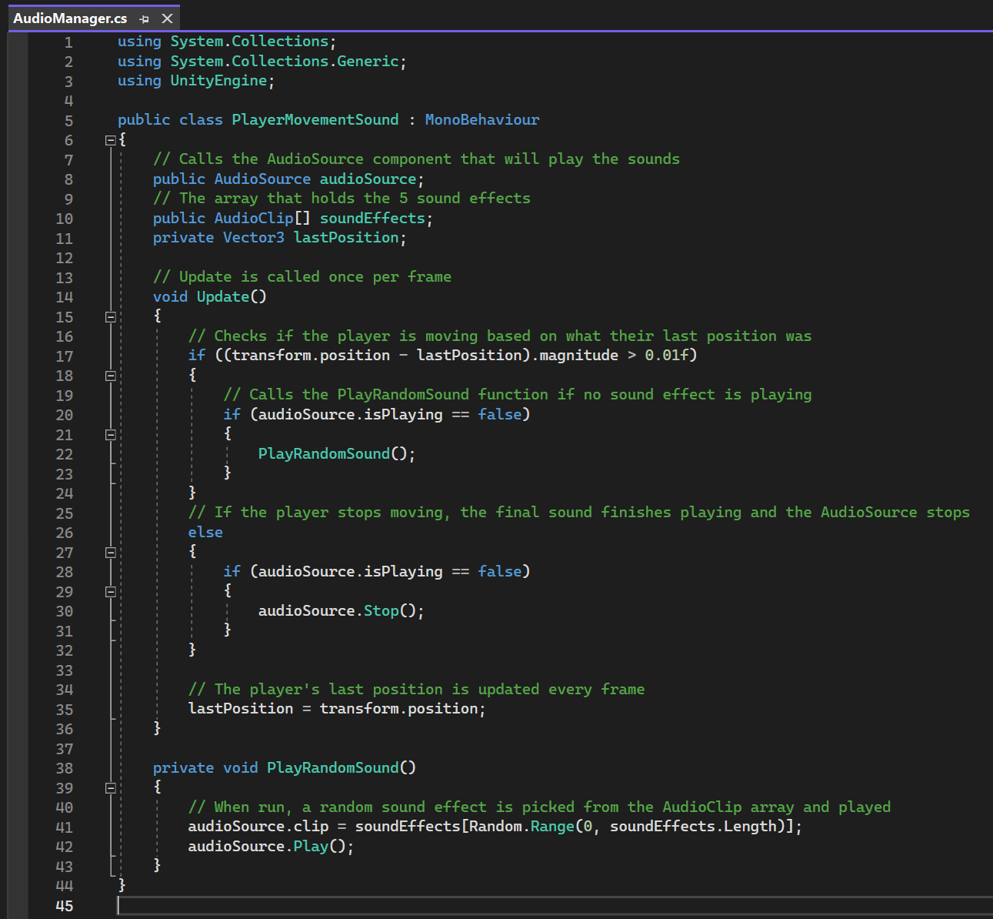

8. Attach the script to the player, and set the Audio Source as the one created in step 3. Drag the audio clips from the audio folder to the array.

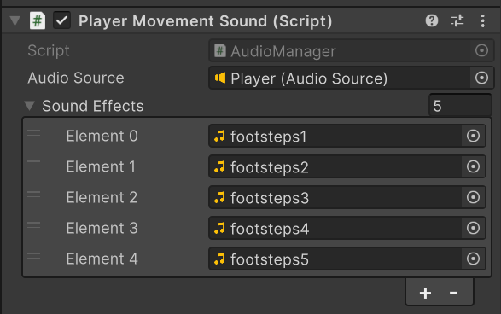

9. As the player moves, the audio clips should play in a random order and silence when the player stops.

